Tip calculator

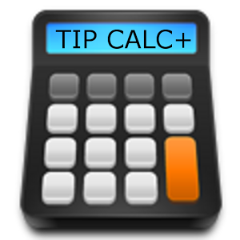

My program is about calculating tips. It asks you about the total of your meal, how was the service, ask you to choose the percentage you would like to tip, and at the end it will add the tip you chose to the total of your meal.

The idea behind my project is that because I work as waiter. I have seen people struggle calculating how much they have to tip. Some just do the total they would like to pay. Some ask the waiter to do the math for them.

Definitely, such program will be a huge benefit to the diners and waiters.

**How the program works:**

-The code I choose is based on functions.

-It sets 3 functions: one for bad service, one for good service and one for excellent service.

-Each function uses a specific percentage and calculates the total of your meal.

Sample:

